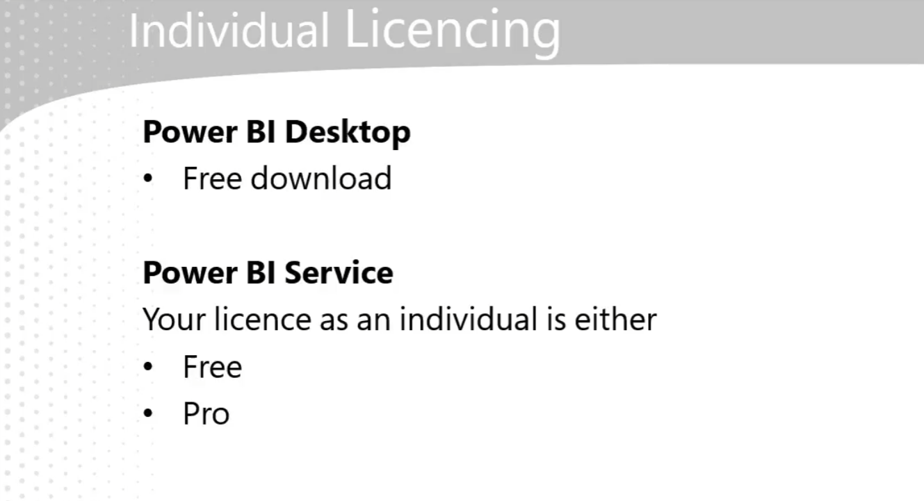

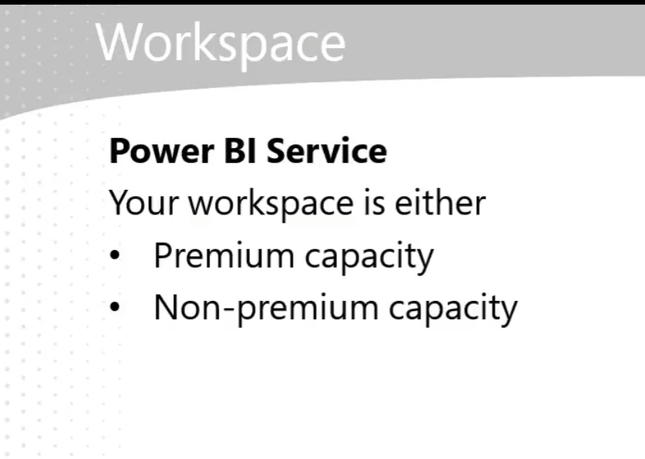

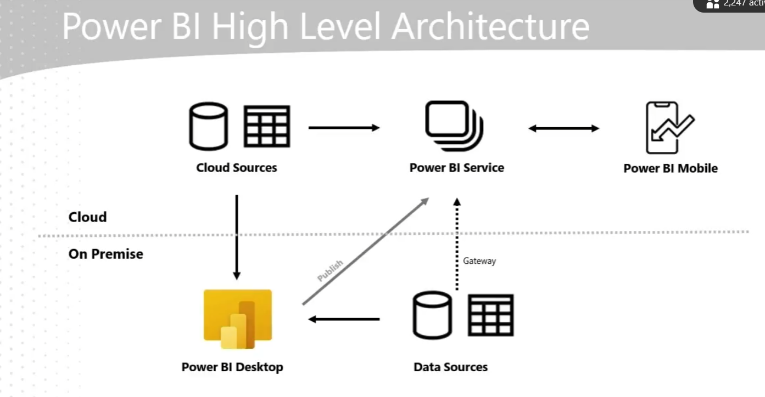

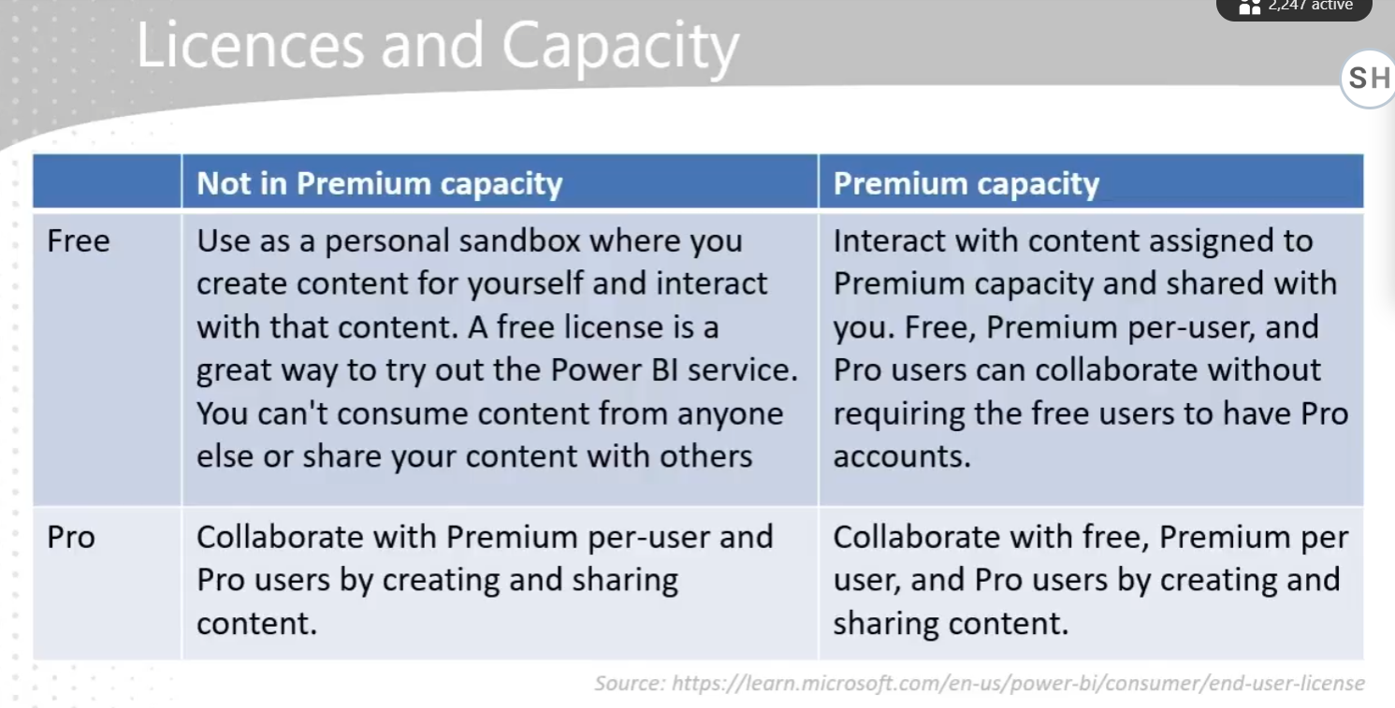

Power BI - Git hub link:

<https://github.com/IterationInsights/Microsoft-Press-Introduction-to-Microsoft-Power-BI-V2>

* **Data Preparation**: As a data analyst, a significant portion of your work involves preparing data for analysis, which includes tasks like removing rows and columns, cleaning data, and merging datasets.
* **Power Query Capabilities**: Power Query simplifies and automates data ingestion and transformation, offering features like data connectors, intuitive data shaping, and recorded transformations to save time.
* **Efficiency**: Using Power Query can potentially reduce data preparation time by up to 80%, making the process more efficient and less manual.

The **M language** is a powerful data transformation language used in Power Query. It allows you to perform complex data manipulations and transformations efficiently. In Power Query, M language records the steps you take to transform your data, making it easier to automate and repeat these processes. This helps streamline data preparation and ensures consistency in your data models.

